**The web application using Node Red**

|  |  |
| --- | --- |
| DATE | 15 NOV 2022 |
| TEAM MEMBERS | DHIVAGAR MK (TEAM LEAD)  BALAYOGESWARAN S  GOBI R  ABINESH R |
| Team ID | PNT2022TMID09958 |
| PROJECT NAME | SMART SOLUTIONS FOR RAILWAYS |

PASSENGER DATA:

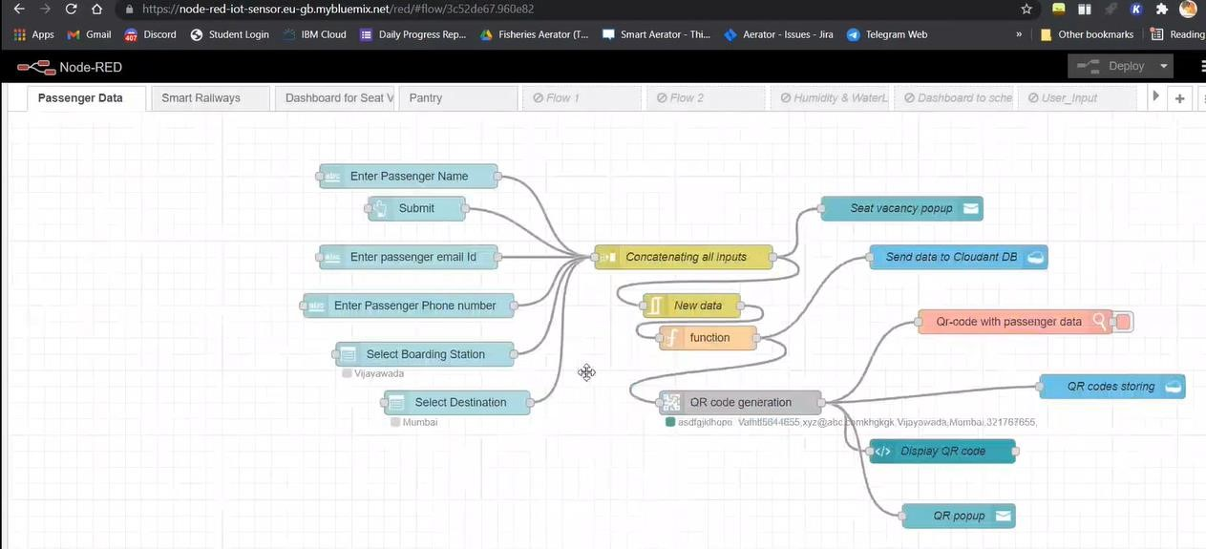

Smart Railways:

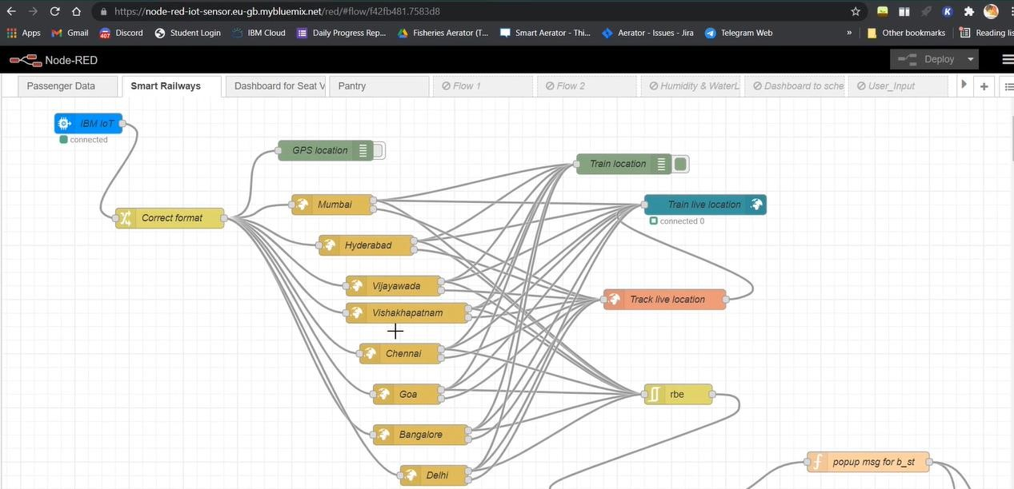

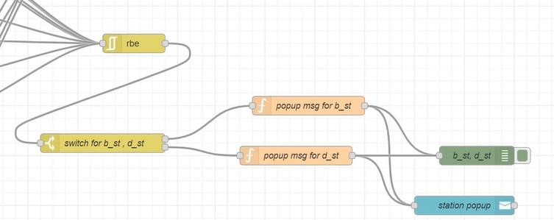

Dashboard for seat vacancy:

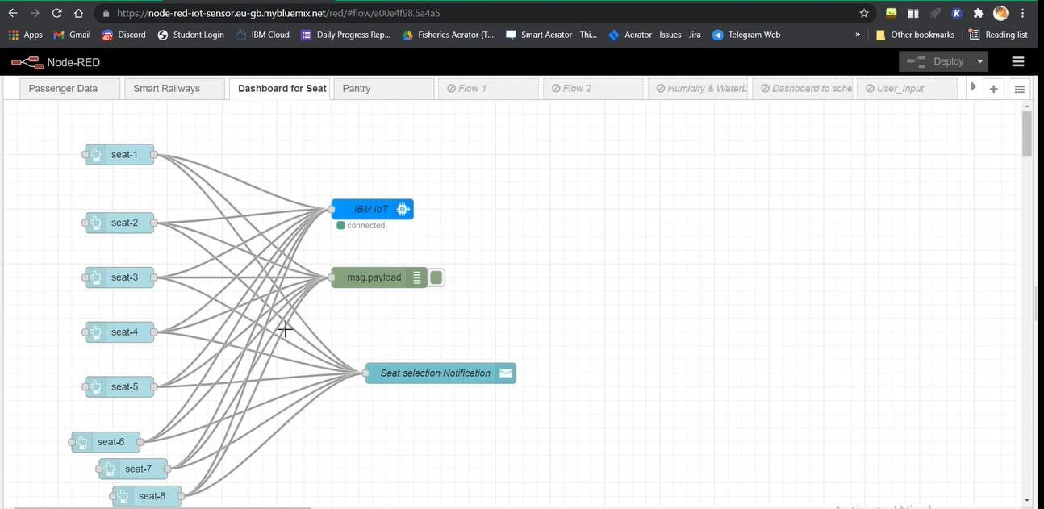

Pantry:

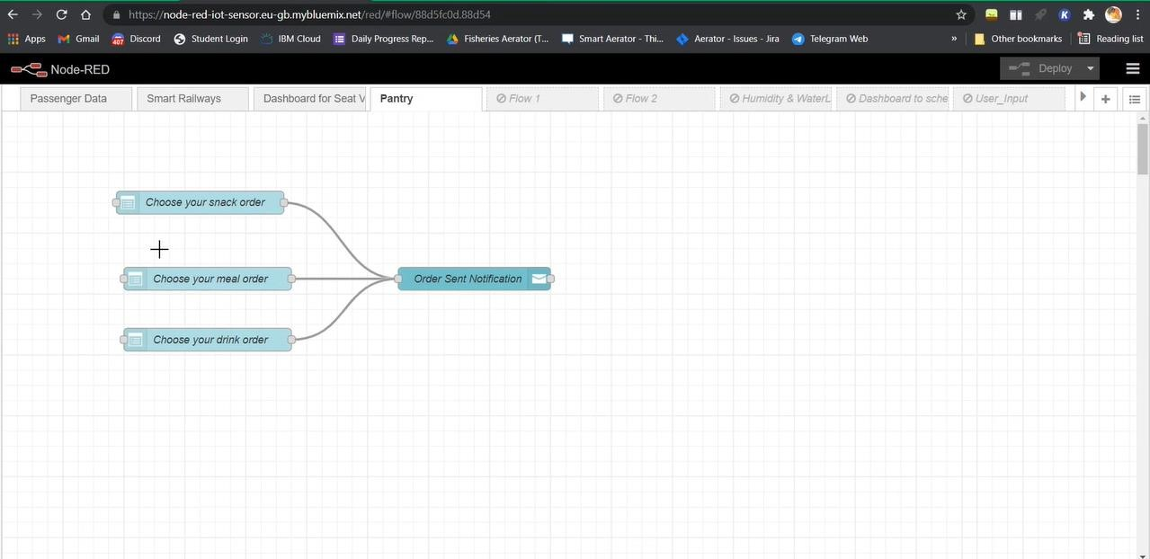

Tc:

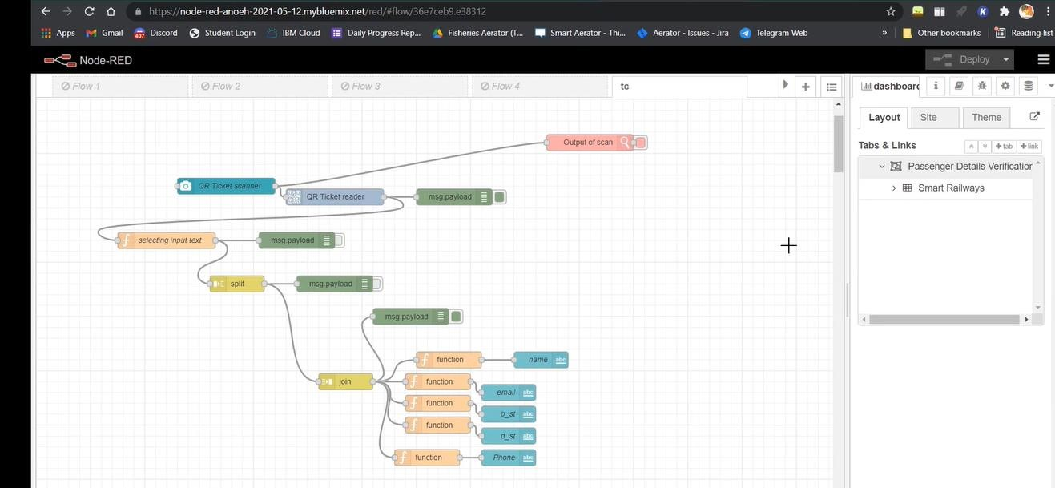

Scanned output at tc:

